John,

The key questions that we need to answer in general terms are 1) how shall we decide what subsystems to do Idealized Design with and 2) how shall we integrate the idealized designs into a coherent whole.

I am including a graphic that a large group created a year ago in Spokane—their vision what a health community looks like:
Below the graphic is a textual summary of the same material. After that I include a graphic and word cloud from two sessions in Oregon.
This is what be have going into the November 19th session in Spokane where we intend to move forward with something that leads into real Idealized Design work as well as “Mess Analysis” and reference projections.

I have included the e-mail that I sent you and Larry last week, at the end of this string.

Looking forward to the call tomorrow.

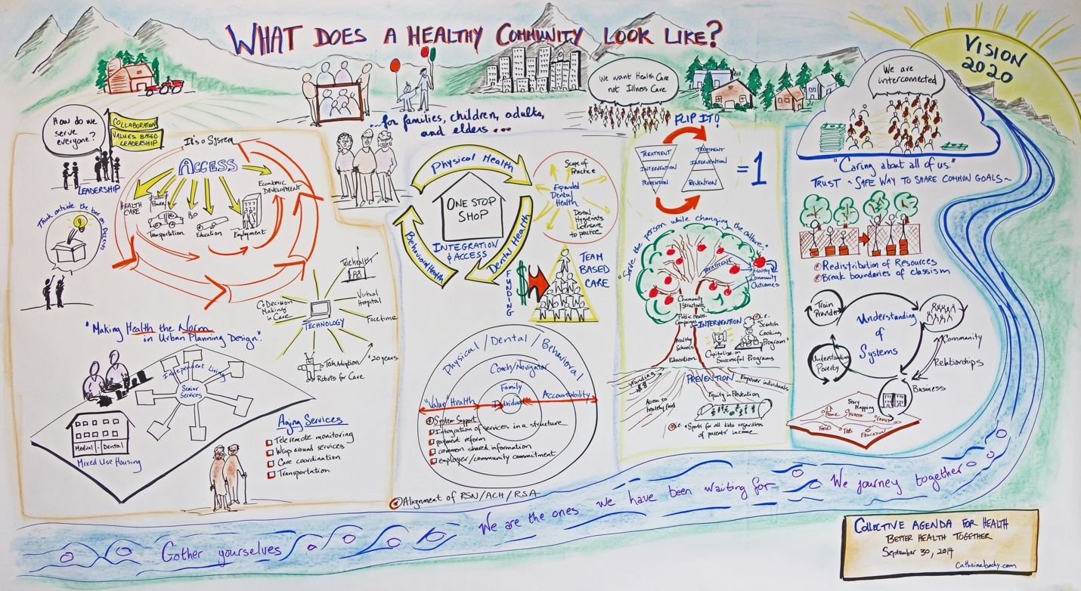

VISION 2020 Collective Agenda for Health -- BHT Sept. 30, 2014
Leadership
Values based
For collaboration
Outside the box
Understanding of Systems
Policy
Business
Providers
Community
Families (Children, Adults, Elders)
Place
Housing
Community Services
Schools
Equity in Prevention
Healthy food
Empower individuals
Health
Access to all services
Medical
One stop shop
Support System
Integration of health services
Physical / Dental / Behavioral
Coach/ Navigator
Family
Individual
——————————————————————
Oregon

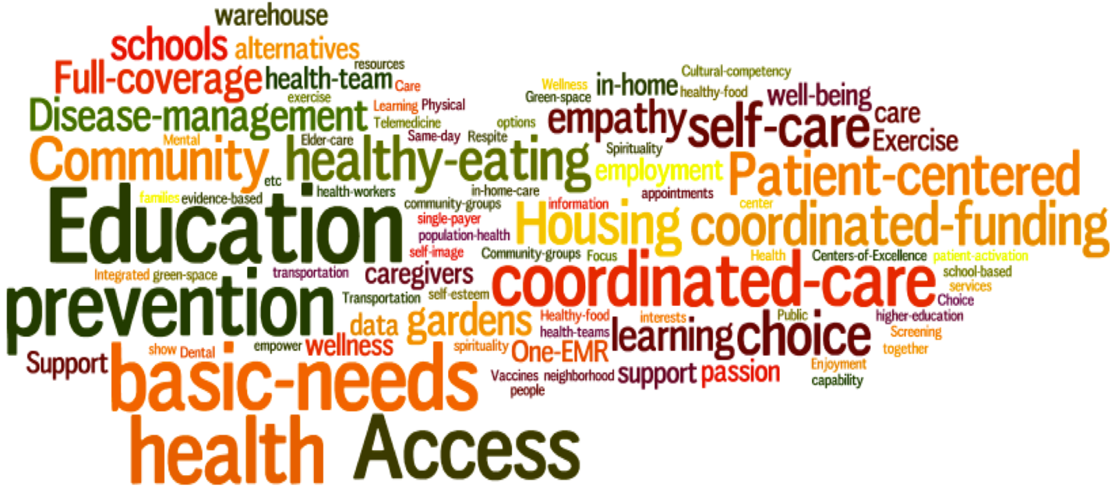
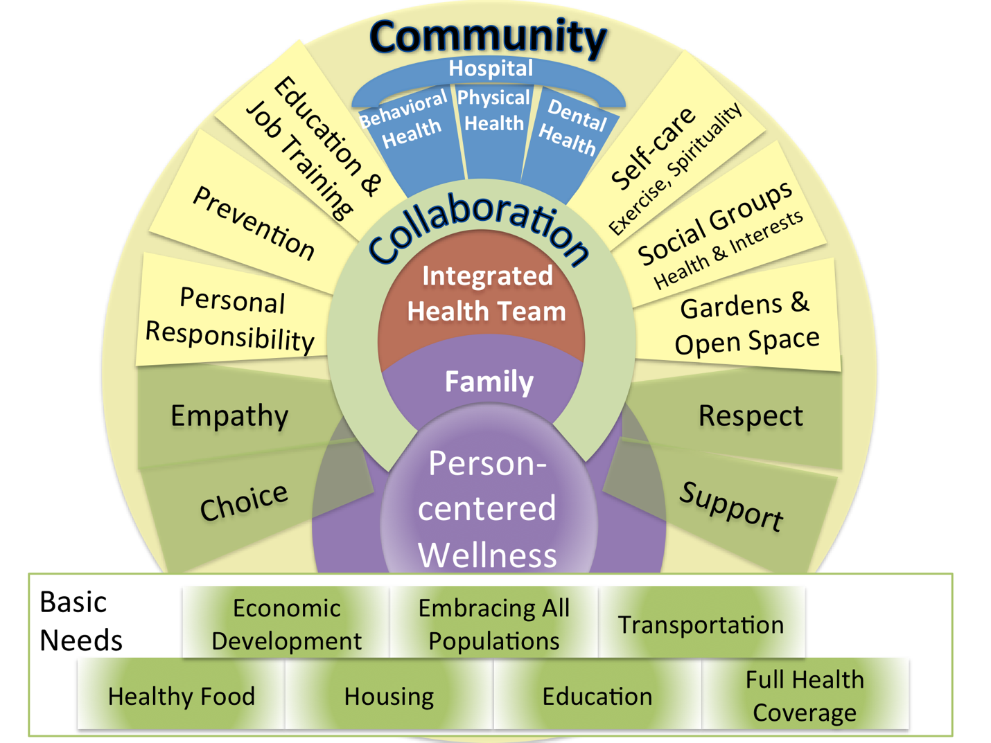

———————————————

CHALLENGE:
How to organize for a process of interactive, integrative idealized design of a community level system of health which spans six counties?

SITUATION
- Washington State, through the Washington Health Care Authority (HCA) hopes to integrate many parts into a functioning the "system of health"
- They have a vague conception of Accountable Community of Health (ACH) and are attempting to cause their emergence
- Nine Regions covering 39 counties
- 1115 Waiver is great opportunity and great stress on everyone
- Better Health Together (NE WA)
  - Empire Health Foundation
  - Six or more Counties
  - HCA designation of BHT as an ACH
  - Numerous Sectors
  - Many Associations
- All voluntary
  - Therefore it must be inclusive and PARTICIPATORY
- Need sufficient structure to create "system self-awareness" that can then manage necessary emergence (self-organization)
- I think that "Interactive Planning" is the needed approach

Cambridge Management Group (CMG)
- Circular Model
  - 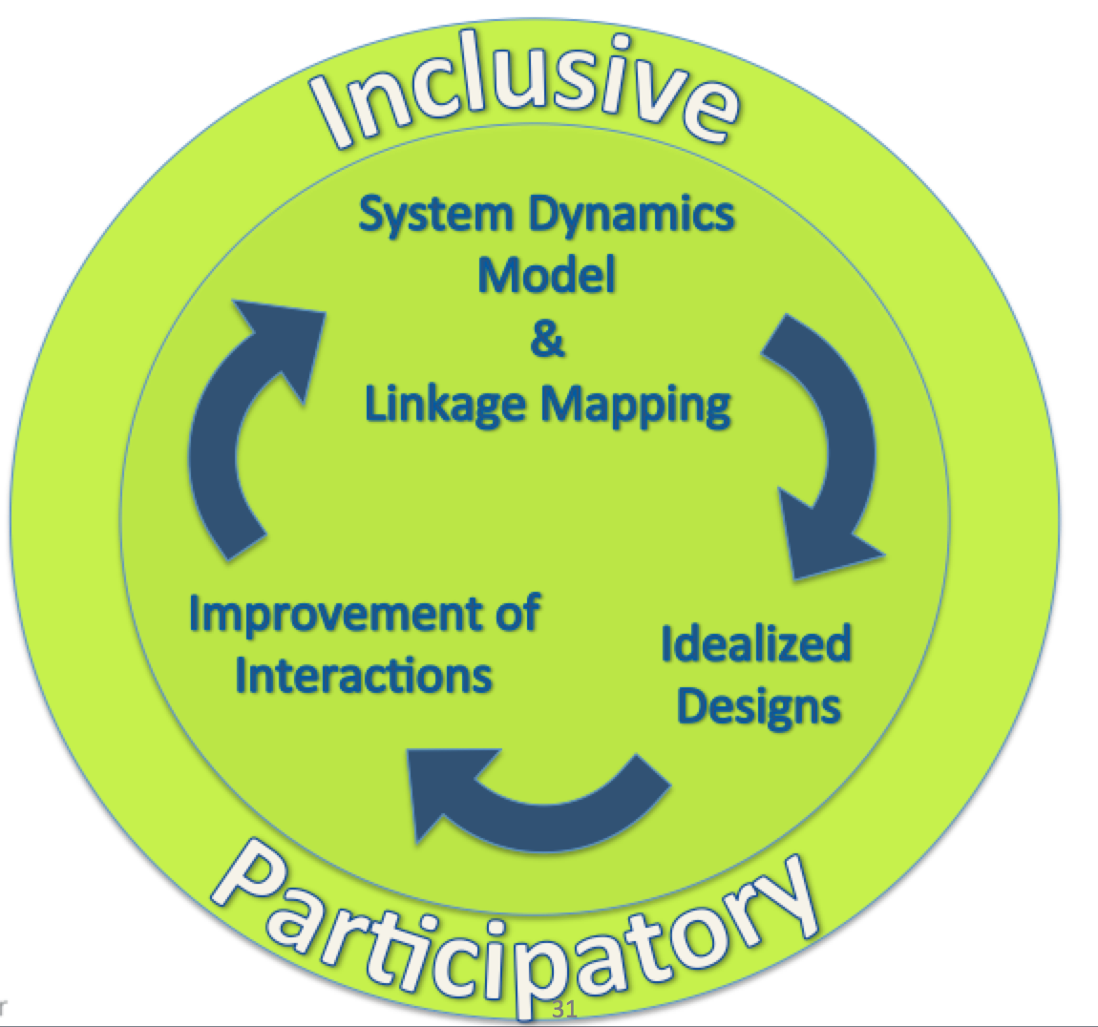
- We can use ReThink Systems Dynamics Modeling and Linkage Mapping to "formulate the mess" for ACHs

- Ideal Design creates the possibility of shared futures for the constituents of ACH regions
- Management of Policies, Programs, Projects and Processes is the "business" of each ACH
- OUR CHALLENGE
  - How to organize for a process of interactive, integrative idealized design of a community level system of health which spans six counties?
I6 DESIGN
- Interactive
- Inclusive
- Involved (participatory)
- Integrative
- Idealized
- Iterative
- Identify the sets of people and institutions that should create idealized designs and linkage maps together so that the co-create policies, programs, projects and processes that they commit to.
- We must take into account several categories of parts:
  - Counties and Districts
  - Sectors and sectorial associations (Thurston Thrives: Community Resilience Strategy Map)
    - CLINICAL / Emergency Care (Thurston Thrives: Clinical / Emergency Care Strategy Map)
    - Purchasers
    - Payers (insurers)
    - Hospitals
    - Medical Clinics
    - RNSs (Behavioral Health)
    - Addiction and Recovery Services
    - Oral Health
    - Long term care
    - Community Health Workers and Non-traditional Health Workers
    - Tribes
    - Local Government
    - Public Health Departments / Regions
    - Crisis intervention
    - Family Support
    - Child Welfare
    - Environment (Place) (Thurston Thrives: Community Design Strategy Map) and (Thurston Thrives: Environment Strategy Map)
    - Criminal Justice / Safety (Thurston Thrives: Public Safety and Justice Strategy Map)
    - Transportation
    - Food (Thurston Thrives: Food Strategy Map)
    - Housing (Thurston Thrives: Housing for Health Strategy Map)
    - Schools and Early Learning (Thurston Thrives: Child & Youth Resilience Strategy Map) and (Thurston Thrives: Education Strategy Map)
    - Foundations and Grants
    - Economic Development (Thurston Thrives: Economy Strategy Map)
  - Program types (ReThink Model)
    - RISK
      - Enable Healthier Behaviors
      - Reduce Environmental Hazards
      - Reduce Violent Crime
      - Create Student Pathways to Advantage
      - Create Family Pathways to Advantage
    - CARE
      - Improve Physical Illness Care
      - Improve Mental Illness Care
      - Support Self-Care
      - Reduce Hospital-Acquired Infection
    - CAPACITY
      - Redesign Primary Care for Efficiency
      - Increase Hospital Efficiency
      - Recruit Primary Care Providers - General
      - Recruit Primary Care Providers - FQHC
    - COST
      - Offer Pre-Visit Consultation
      - Create Medial Homes
      - Reform Medical malpractice
      - Expand Hospice Use
      - Coordinate Care
      - Improve Post-Discharge Care
    - FUNDING SOURCES
      - Establish Innovation Fund
      - Move to Contingent Global Payments
      - Reinvest a Negotiated Split of Health Care Cost Savings

Possible nesting of design entities to integrate Idealized Designs and Improve Linkages (work flows) between the parts
- 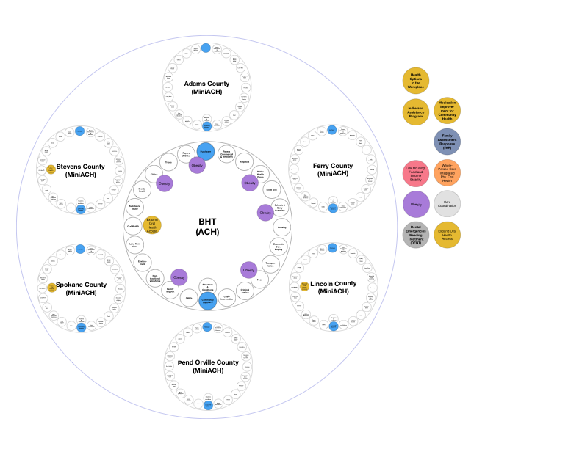
- Associations
- How to Integrate the Idealized Designs, Integrate the Linkage Maps
- And then how coordinate the programs, projects and process changes among participants and across system levels?

